Creation of new Project in sandbox:

1. Click on the tiny dropdown triangle on the top left part of the screen.
2. Select Create New Project.

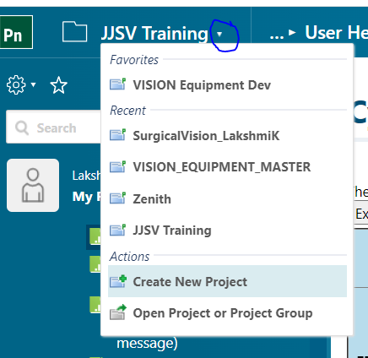

1. In the Create New Project window, Enter the Project ID, Location and Tacker Prefix. Click on Next.

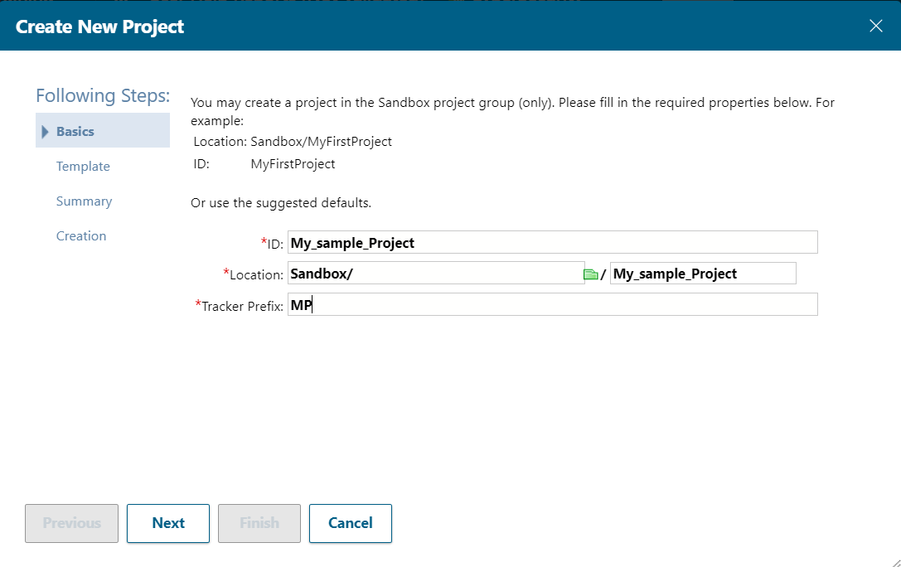

1. Select the template to used for creating the project.

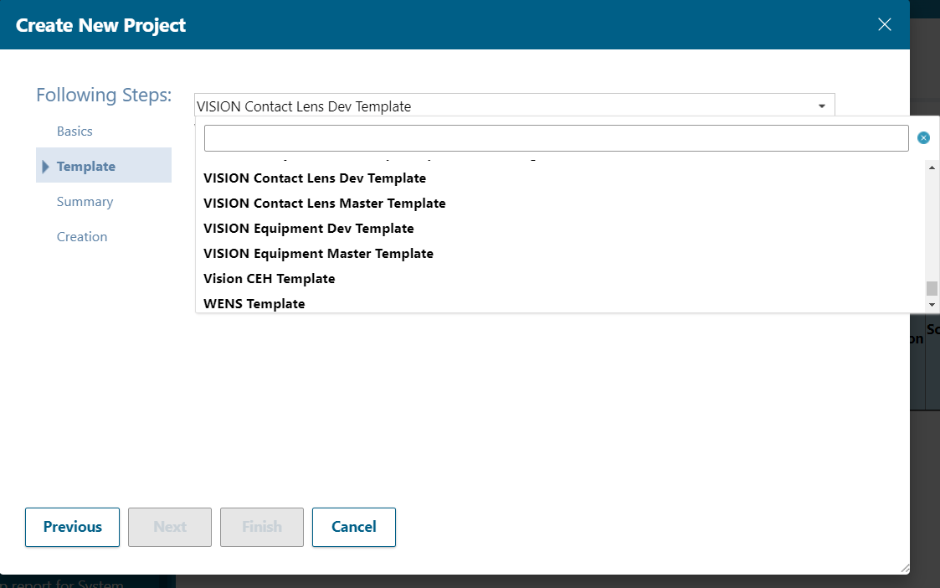

1. Enter Project Name and click on Next.

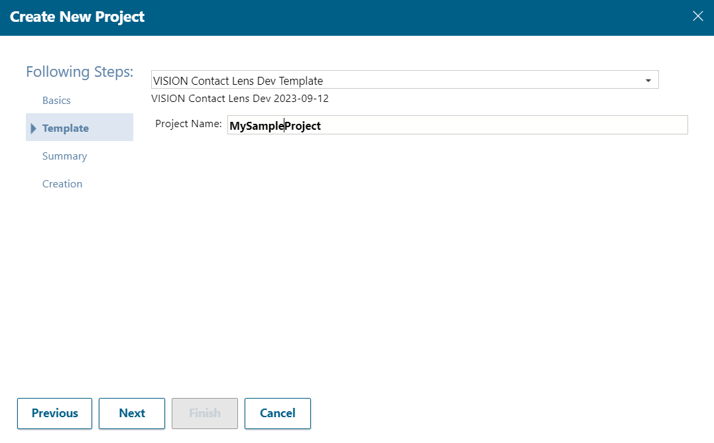

1. Review the details provided: Location, ID, Template, Tracker Prefix as shown below. Click on Next. A new Project is created in sand box.

